Tables and Figures

Table 1. Results of Simulation and SWS Algorithm on 6 Estimated Data Sets.
Sim | Del. Eff. | Prop. Outside C.I. | Dev. p-value | Model r² | Accept. Ratio
1 | No | 0.316 | 0.064 | 0.746 | 0.183
2 | Yes | 0.924 | 0.054 | 0.715 | 0.193
3 | No | 0.013 | 0.036 | 0.715 | 0.183
4 | Yes | 0.772 | 0.094 | 0.592 | 0.201
5 | No | 0.266 | 0.070 | 0.557 | 0.175
6 | Yes | 0.165 | 0.127 | 0.235 | 0.186
Note: All models use 4 independent MCMC chains of 250,000 each for a total draw of 1,000,000. Effects are calculated based on BMA using BIC. Dev. p-value reports the absolute value of the difference between Bayesian p-value of the mean and the target p-value of 0.5. Smaller value indicates better fit.

Table 2. [Some Summary of the Empirical Example]

Figure 1. For a Continuous Variable ranging 1-8, probability that the current value is equal to the prior value, i.e. constitutes a new window break over two sets of Dirichlet hyperparameters.

Note: 1,000 draws applying equations __ through __ in step one of the SWS, using fixed hyperparameters for the Dirichlet as outlined in the right margins. The probability for the first value is equal to 1 in all cases, because the first value will by definition always constitute a new window break, regardless of the alpha value.

Figure 2. Best Fitting Exploratory Simulation Model Comparing SWS Estimates to True Effect.

Note: Simulation 3 from Table 2.
n=1,000. BMA for 1,000,000 MCMC draws from 4 independent chains of 250,000 each.
Similar plots for all 6 simulations appear in the Appendix as Figure S-1.

Figure 3. Empirical example of Stochastic Window Sampler for APC effects of gender egalitarianism.
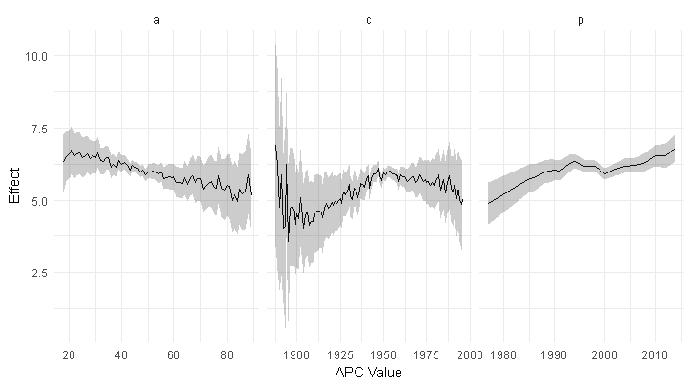

Note: BMA from 4 chains of 250 models each for a total of 1,000 models of different window constraints.
Appendix A – Supplemental Tables and Figures
Table S-1. Table of Effects Used to Simulate Data.
Sim | Age | Age-Squared | Period | Period-Squared | Cohort | Cohort-Squared
1 | -0.836 | 0.075 | -0.727 | -0.048 | 0.246 | 0.031
2 | 0.000 | 0.000 | -0.727 | -0.048 | 0.246 | 0.031
3 | -0.044 | -0.032 | 0.261 | -0.057 | -0.181 | 0.079
4 | -0.044 | -0.032 | 0.000 | 0.000 | -0.181 | 0.079
5 | -0.252 | 0.027 | 0.057 | 0.041 | 0.057 | -0.037
6 | -0.252 | 0.027 | 0.000 | 0.000 | 0.057 | -0.037

Figure S-1. Effects to Actual Estimates for All Six Exploratory Simulations.

Note: Simulation Summaries Reported in Table 1. Dashed line is estimate; shading indicates 95% Intervals. Solid Line is True Effect.

Appendix B. R-Code for SWS Algorithm.

#note that for space constraints, calculations and functions unrelated to SWS #are not shown,
#all code, is publicly available on First Author’s github page: [URL BLINDED]

library(MCMCPack) #for Dirichlet distribution

window.sample=function(var,alph){
#input is continuous of a,p,c
#alpha is a vector the length of unique entries in var FOR dirichelet
#output is factor with uniform, random window constraints
vals=unique(var) #center on 0; assume continuous
len=length(vals)

alph=unlist(alph)

dp=rdirichlet(1,alph)
#segment the stick
segments=round(cumsum(dp*len))
#identify changes in segments
sb=segments
for(i in seq_along(segments)){
if(i==1){next}
sb[i] = segments[i]-segments[i-1]
}

#id inclusive breaks
breaks=vals[sb>=1]

#because breaks are *inclusive*, must include min-1; ensure max
if(min(breaks)>(min(var)-1)){
breaks=c((min(var)-1),breaks)
}
if(max(breaks)<max(var)){
breaks=c(breaks,max(var))
}

wins=window(var,breaks=breaks)

return(wins)
}

#set of numbers of random samples
n.samples=250

#holder df for model summary data
win = data.frame(a=numeric(), p=numeric(), c=numeric())
breaks=list(a=list(),p=list(),c=list())

d = c('a','p','c')
dl = c(length(unique(tdat$a)),length(unique(tdat$p)),length(unique(tdat$c)))
names(dl) = d

#set starting values
all.alphas = lapply(d,function(x) data.frame(t(rep(dl[x],length(unique(tdat[,x]))))))

names(all.alphas) = d #names(all.nwins) = d

#accept rate
acc=0
#count boundary conditions rejections
bound=0

#mcmc sampler (prior model probabilities are equal)
for(s in 2:n.samples){

#draw new alphas
for(d in seq_along(all.alphas)){rownames(all.alphas[[d]]) = 1:nrow(all.alphas[[d]])}

#test for boundary constraint
if(any(unlist(all.alphas)<0)){

#reject
bound=bound+1
out.al=sum(unlist(all.alphas)<0)
cat('\n\nOut-of-Sample-Space Warning.\n\n')

#reset if boundary constraint hit
for(d in seq_along(all.alphas)){
all.alphas[[d]][s,]=all.alphas[[d]][s-1,]
#note that this may still sample different windows, just uses the same hyper-param
}

}

#skip if unideintified
la = length(levels(x$a)) == length(unique(tdat$a))
lp = length(levels(x$p)) == length(unique(tdat$p))
lc = length(levels(x$c)) == length(unique(tdat$c))
if(all(la,lp,lc)){
for(d in seq_along(all.alphas)){
all.alphas[[d]][s,]=all.alphas[[d]][s-1,]
}
}

#draw random window samples
x$a=window.sample(x$a,all.alphas$a[s,])
x$p=window.sample(x$p,all.alphas$p[s,])
x$c=window.sample(x$c,all.alphas$c[s,])

#linear model
#lin_gibbs is a bayesian gibbs sampler derived from Lynch 2007 pp. 172-173

#reassign random references to each vector
a.lev=length(levels(x$a)); a.b = sample(1:a.lev,1)
p.lev=length(levels(x$p)); p.b = sample(1:p.lev,1)
c.lev=length(levels(x$c)); c.b = sample(1:c.lev,1)

form.c = as.formula(paste("~C(a,contr.treatment(a.lev,base=a.b))+
C(p,contr.treatment(p.lev,base=p.b))+
C(c,contr.treatment(c.lev,base=c.b))"))

xmat = model.matrix(form.c,data=x)
m = allmods[[s]] = lin_gibbs(y=y,x=xmat)

#calculate grand means to evaluate conditional effects from linear model
#scopedummy is helper function that expands xhat to dimension of unique continuous values
grand.means = data.frame(
a = window(mean(tdat$a),breaks=attr(x$a,'breaks')),
p = window(mean(tdat$p),breaks=attr(x$p,'breaks')),
c = window(mean(tdat$c),breaks=attr(x$c,'breaks'))
)

grand.means$a=relevel(grand.means$a,ref=a.b)
grand.means$p=relevel(grand.means$p,ref=p.b)
grand.means$c=relevel(grand.means$c,ref=c.b)

grand.means=(model.matrix(form.c,grand.means))

blockdat=lapply(x,scopedummy)
blockdat$a = relevel(blockdat$a,ref=a.b)
blockdat$p = relevel(blockdat$p,ref=p.b)
blockdat$c = relevel(blockdat$c,ref=c.b)

predat=lapply(blockdat,FUN=function(x)
model.matrix(~.,data=as.data.frame(x)))

effects[[mnum]] = xhats[[mnum]] = list()
#xhat = list()

effects[[mnum]]$bic=m$bic

avtm=(avtm*(length(allmods)-1)+Sys.time()-tm)/length(allmods)
tm=Sys.time()

if(s==2){next} #skip because evaluations do not exist for first iteration...

#apply selection criterion

#bayes factor approximation
bf=exp((allmods[[s]]$bic-allmods[[s-1]]$bic)/2)
R = min(1,bf)
#R = min((allmods[[s]]$bic/ allmods[[s-1]]$bic),1)
#print(R)
if (R < runif(1)){
acc = acc+1
} else {

for(d in seq_along(all.alphas)){
#all.nwins[[d]][s]=all.nwins[[d]][s-1]
all.alphas[[d]][s,]=all.alphas[[d]][s-1,]
}

}

}#end sampling loop

k=min(bics)
d=-.5*(bics-k)
w=exp(d)/sum(exp(d))

k = min(bics_prime)
d=-.5*(bics_prime-k)
w_prime=exp(d)/sum(exp(d))

#w is used to calculate BMA weight and sampler for estimates

